Literacy support worksheet answers

3.1 Scientists refine models and theories over time

Pages 66–69

The history of the periodic table

1 Who created the modern periodic table?

Dmitri Mendeleev

2 Why did Mendeleev leave gaps in the periodic table?

Mendeleev left gaps for undiscovered elements

3 How many elements did the ancient Greeks believe in?

Four

4 Name the two steps Mendeleev took to organise the elements on the periodic table using cards.

• Ordering by atomic weight

• Ordering into groups with similar properties

5 Match each famous scientist with their contribution to the development of the periodic table.

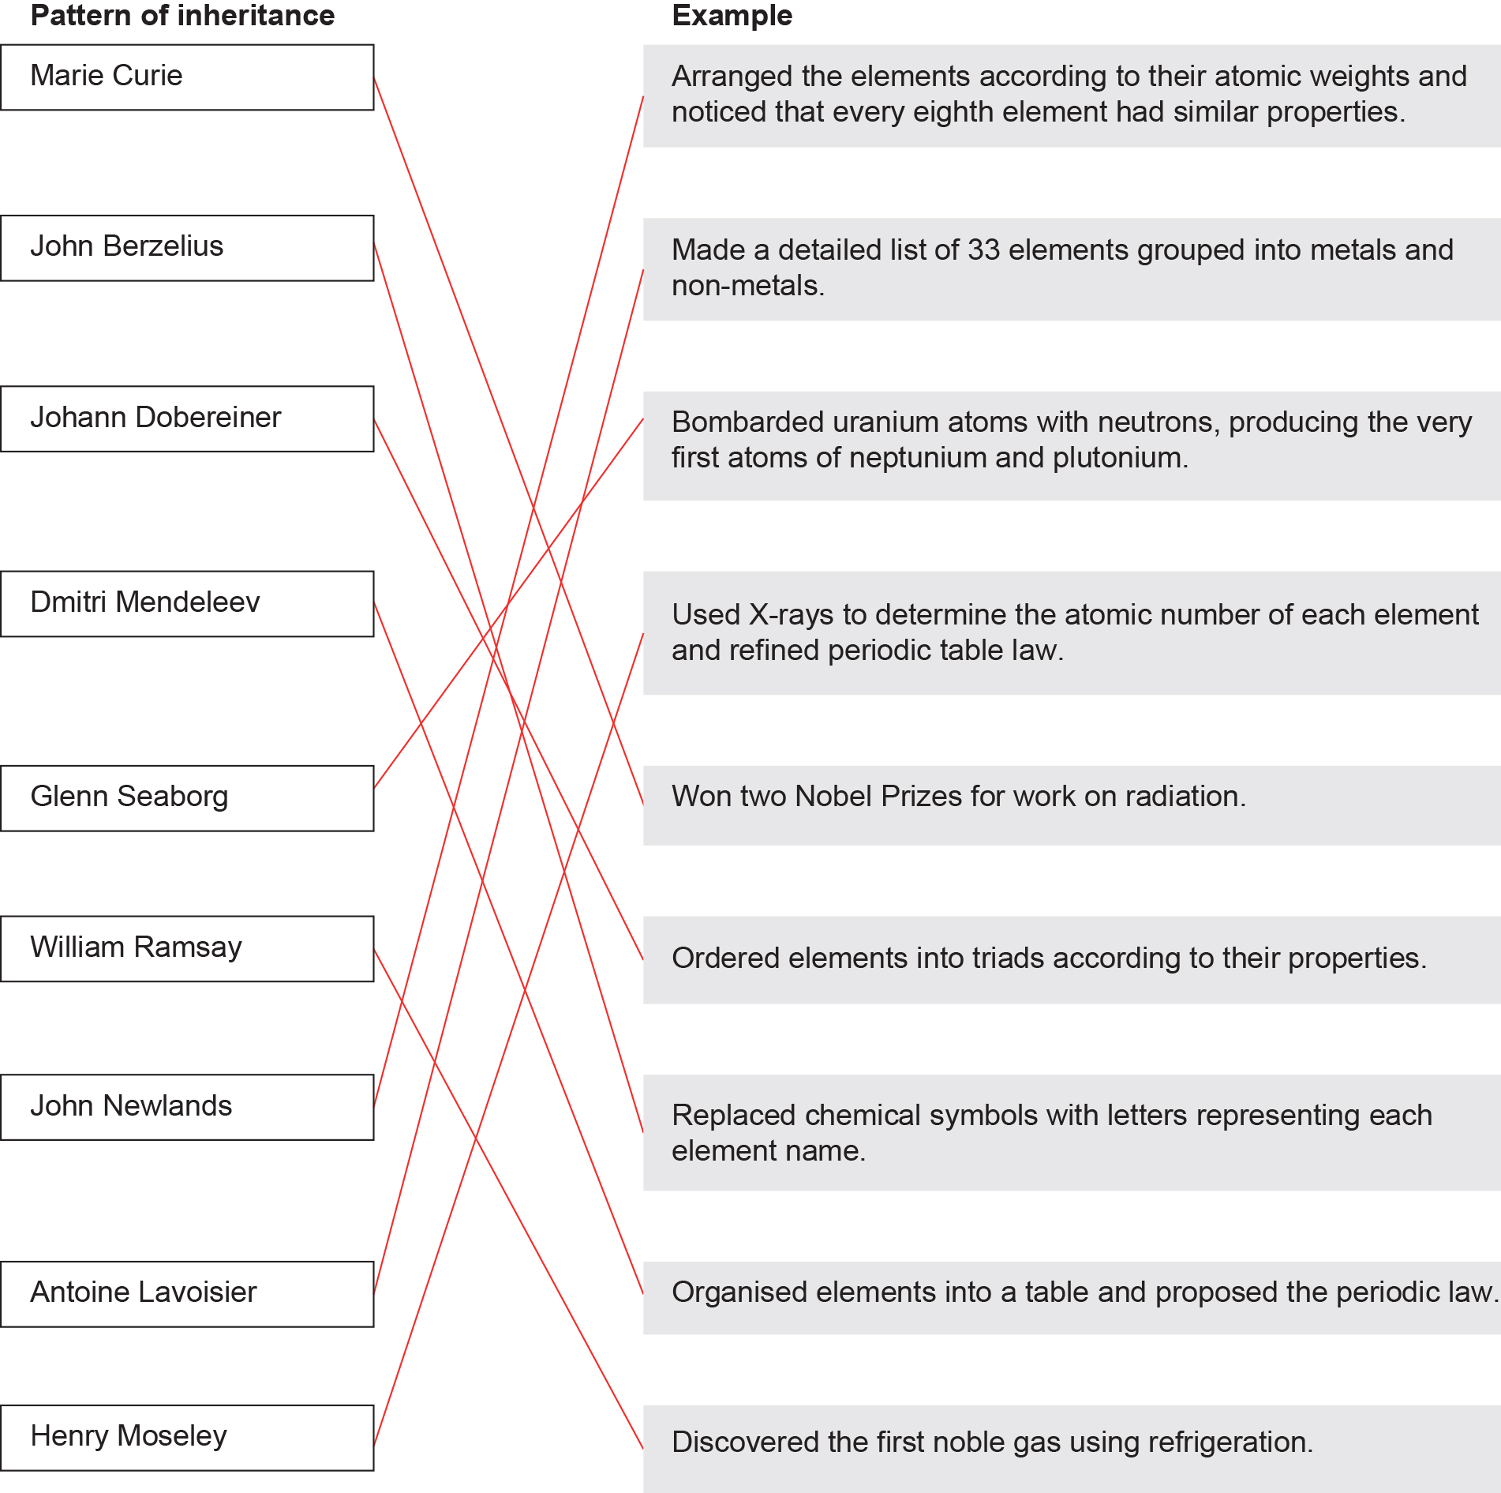

Word detective – Fill in the blanks

6 Fill in the blanks in the timeline below to show how the periodic table has changed.

|  |  |  |
| --- | --- | --- |
| Scientist | Year | Discovery |
| Ancient Greeks | 2000 years ago | Thought everything was made of four ‘elements’ mixed together in different ratios. |
| Robert Boyle | 1661 | Suggested that an element was a substance that cannot be broken down into a simpler substance in a chemical reaction. |
| Antoine Lavoisier | 1789 | Made a detailed list of 33 elements grouped into metals and non-metals. |
| Jakob Berzelius | 1820s | Replaced the geometric patterns used as chemical symbols with letters that were an abbreviation of the element’s name. Also, used the weight of hydrogen to develop an organised system of atomic weights, with all remaining elements believed to have a whole number above 1. |
| Johann Dobereiner | 1829 | Grouped 40 elements into triads according to their properties. These groupings were important in identifying patterns of behaviour, which helped with more accurate predictions about atomic structures. |
| John Newlands | 1864 | Arranged the elements according to their atomic weights, and noticed that every eighth element had similar properties. This pattern was considered a recurring or ‘periodic’ feature among the elements. |
| Dmitri Mendeleev | 1869 | Wrote the names and properties of each element on small cards and arranged them in order of atomic weight. The cards were then rearranged, maintaining their order, into groups with similar properties, creating the modern periodic table. |
| William Ramsay | 1894 | Used the technology of refrigeration to remove water, carbon dioxide, oxygen and nitrogen from air, but found some unknown gas left behind. This was argon, the first of the noble gases to be discovered. |
| Marie Curie | 1911 | Identified and purified elements of the periodic table. Also, won two Nobel Prizes for her work on radiation. |
| Henry Moseley | 1913 | Used X-rays to determine the atomic number of each element and refined periodic table law. |
| Glenn Seaborg | 1940 | Bombarded uranium atoms with neutrons. This produced the very first atoms of neptunium and plutonium. |

Literacy support worksheet answers

3.2 The structure of an atom determines its properties

Pages 70–73

Atomic structure

1 What is the atomic number and name of an atom determined by?

The number of protons

2 Fill in the equation below:

Relative atomic mass = number of protons + number of neutrons

3 On the periodic table, what is a horizontal row called?

A period

4 On the periodic table, what is a vertical column called?

A group

5 What is the equation to calculate how many electrons in a shell?

Electrons in a shell = 2n2

6 Label, on the shell diagram below, where the electrons would be found for an oxygen atom.

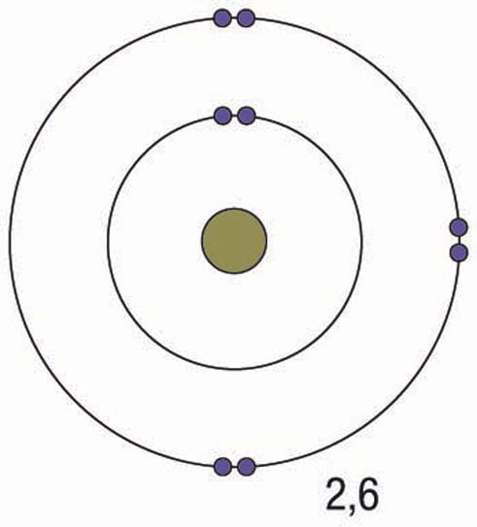

7 Calculate the number of protons, neutrons and electrons for each atom using the periodic table and a calculator. Fluorine has been done for you.

|  |  |  |  |
| --- | --- | --- | --- |
| Atom | Number of protons =  atomic number  (found at the top of the letter) | Number of neutrons =  mass number  (found at the bottom of the letter)  – atomic number | Number of electrons  =  atomic number |
| Nitrogen (N) | 7 | 14 – 7 = 7 | 7 |
| Oxygen (O) | 8 | 16 – 8 = 8 | 8 |
| Fluorine (F) | 9 | 19.00 – 9 = 10 | 9 |
| Neon (Ne) | 10 | 20.18 – 10 = 10.18 | 10.18 |

8 Draw the electron configuration for the following elements, using the rules in the Bohr table below.

Bohr model of the atom

|  |  |
| --- | --- |
| Shell number form the nucleus outwards (n) | Maximum number of electrons in the shell (2n²) |
| 1 | 2 |
| 2 | 8 |
| 3 | 18 |
| 4 | 32 |

|  |  |  |  |
| --- | --- | --- | --- |
| Nitrogen  L:\1. Publishing and Editorial\1. Product\Oxford Science\Oxford Science 10\3. Extras\6. Student worksheets\Artwork\4. Final jpgs\SW0304_01095.jpg  2,5 | Oxygen  L:\1. Publishing and Editorial\1. Product\Oxford Science\Oxford Science 10\3. Extras\6. Student worksheets\Artwork\4. Final jpgs\SW0305_01095.jpg  2,6 | Fluorine  L:\1. Publishing and Editorial\1. Product\Oxford Science\Oxford Science 10\3. Extras\6. Student worksheets\Artwork\4. Final jpgs\SW0306_01095.jpg  2,7 | Neon  L:\1. Publishing and Editorial\1. Product\Oxford Science\Oxford Science 10\3. Extras\6. Student worksheets\Artwork\4. Final jpgs\SW0307_01095.jpg  2,8 |
| Phosphorus  L:\1. Publishing and Editorial\1. Product\Oxford Science\Oxford Science 10\3. Extras\6. Student worksheets\Artwork\4. Final jpgs\SW0308_01095.jpg  2,8,5 | Silicon  L:\1. Publishing and Editorial\1. Product\Oxford Science\Oxford Science 10\3. Extras\6. Student worksheets\Artwork\4. Final jpgs\SW0309_01095.jpg  2,8,4 | Chlorine  L:\1. Publishing and Editorial\1. Product\Oxford Science\Oxford Science 10\3. Extras\6. Student worksheets\Artwork\4. Final jpgs\SW0310_01095.jpg  2,8,7 | Argon  L:\1. Publishing and Editorial\1. Product\Oxford Science\Oxford Science 10\3. Extras\6. Student worksheets\Artwork\4. Final jpgs\SW0311_01095.jpg  2,8,8 |

Word detective – Match the words

9 Match the following elements with their descriptions.

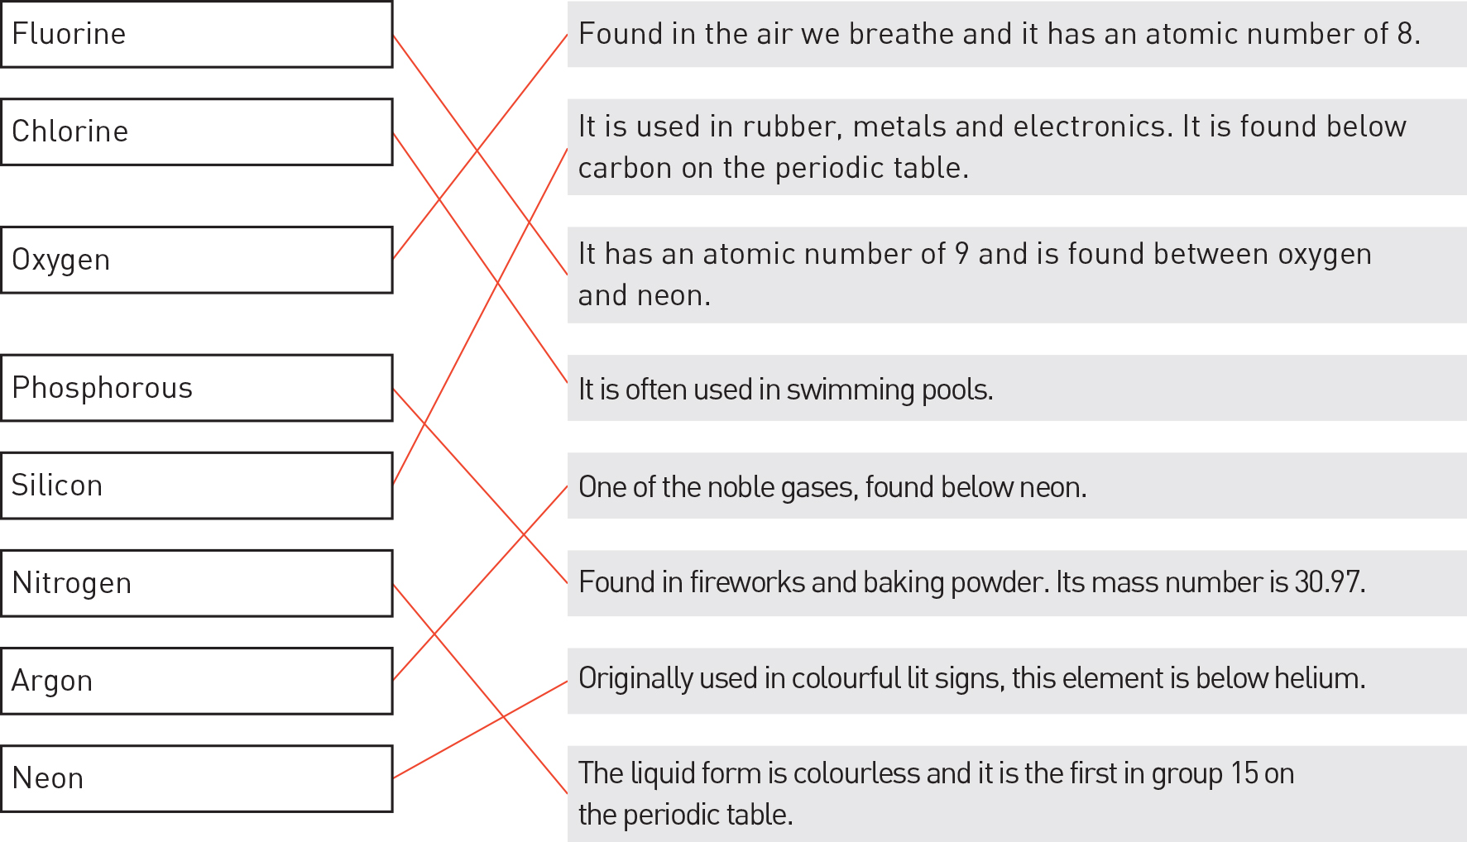

Literacy support worksheet answers

3.3 Groups in the periodic table have properties in common

Pages 74–75

Trends of metals in the periodic table

1 Name five properties that all metals have in common.

• Lustrous (shiny)

• Able to conduct heat

• Able to conduct electricity

• Malleable (can be beaten into a new shape)

• Ductile (can be drawn into a wire)

2 For the three metal groups in the periodic table, fill in the blanks in the table below.

|  |  |  |  |
| --- | --- | --- | --- |
| Name | Alkali metals | Alkaline earth metals | Transition metals |
| Group number | 1 | 2 | 3–12 |
| Properties | • Soft  • React with air to become white  • React violently with water to product hydrogen gas and a basic solution  • More reactive down the group | • Low melting points  • Relatively soft and very reactive, although in general they are not quite as reactive as group 1  • React with water, some strongly, producing hydrogen gas and a basic solution  • More reactive down the group | • Some are magnetic  • Gold and copper are the only metals that are not silvery in colour  • Many form coloured compounds  • Many form more than one compound with a non-metal such as chlorine (e.g. iron forms FeCl2 and FeCl3) |

Word detective – Draw a Venn diagram

3 Draw a Venn diagram and fill it in to show the similarities and differences between alkali metals and alkaline earth metals.

Student diagrams will vary, but will include much of the rearranging of the information in the previous question.

Literacy support worksheet answers

3.4 Non-metals have properties in common

Pages 76–77

Trends of non-metals in the periodic table

1 Name six properties of non-metals.

• Do not conduct electricity or heat well

• Brittle

• Do not reflect light, so they are dull in appearance

• Not ductile (not easily manipulated)

• Have a large range of melting and boiling points

• Some are coloured

2 Where can you find non-metals on the periodic table?

Groups 14–18

3 What do metalloids have in common with metals?

Metalloids conduct electricity.

4 Name two metalloids that are ‘semiconductors’.

Silicon and germanium

5 Where would you find non-metals on Earth?

The atmosphere, the Earth’s crust, and living organisms’ tissues

Word detective – Fill in the table

6 Fill in the table comparing halogens and noble gases. Write the properties as dot points.

|  |  |  |
| --- | --- | --- |
| Name | Halogens | Noble gases |
| Group number | 17 | 18 |
| Properties | • Melting and boiling points increase down the group  • It is the only group in which the elements range from gas to liquid to solid at room temperature  • As you go down the group, they are less reactive  • They are sterilising substances because of the lethal effects they can have on bacteria and fungi | • Low melting points  • Have full valence shells so they are unreactive (inert) – xenon and krypton will react with fluorine under certain conditions  • All gases at room temperature  • Radon is the most dangerous as it is a radioactive gas |

Literacy support worksheet answers

3.5 Metal cations and non-metal anions combine to form ionic compounds

Pages 78–79

Ionic compounds

1 What is the difference between an atom and an ion?

Atoms have a neutral charge (the same number of protons and electrons), whereas ions are atoms that have gained or lost electrons and therefore have a charge.

2 When are electron valance shells most stable?

When they are full and contain eight valance electrons.

3 What is likely to happen in the following examples?

a A valance shell has only 1–3 electrons.

It would lose electrons.

b A valance shell has 7 electrons.

It would gain electrons to make a full shell with eight valance electrons.

4 What is an ion?

An ion is a charged atom.

5 What would happen to the charge of an atom if:

a it lost electrons?

It would become positively charged.

b it gained electrons?

It would become negatively charged.

6 Fill in the blanks for the definitions in the table below.

|  |  |
| --- | --- |
| Word | Definition |
| Cation | Positively charged metal |
| Anion | Negatively charged non-metal |
| Ionic bond | Bonds that form when ions interact |
| Ionic compounds | Compounds held together by ionic bonds |
| Polyatomic ions | Ions that are made up of more than one atom |

7 Complete the following table to demonstrate the number of electrons gained or lost by atoms to form ions. The first and last one have been completed for you.

|  |  |  |
| --- | --- | --- |
| Group number | Number of valence electrons | Number of electrons gained or lost |
| 1 | 1 | Lose 1 |
| 2 | 2 | Lose 2 |
| 13 | 3 | Lose 3 |
| 15 | 5 | Gain 3 |
| 16 | 6 | Gain 2 |
| 17 | 7 | Gain 1 |
| 18 | 8 | Stable |

Word detective – Draw and label

8 Draw the electron configuration of lithium and fluorine, and then redraw these configurations to demonstrate how an electron is donated between the atoms. (Hint: Use the information in Figure 3.26 in the student book to help you.)

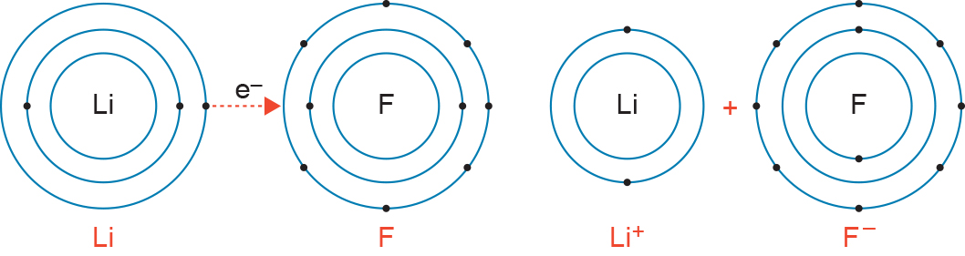

Literacy support worksheet answers

3.6 Non-metals combine to form covalent compounds

Pages 80-81

Covalent bonding

1 What is a covalent bond?

A covalent bond is the sharing of pairs of electrons between atoms.

2 Which types of atoms can covalent bonding occur between?

Two non-metals

3 What do the two atoms share when they convalently bond?

Electrons

4 Sequence the process of a hydrogen molecule forming by ordering the following from 1 to 5.

5 Each atom now has a stable electron configuration because its outer shell is full.

1 Two uncharged hydrogen atoms come close together.

4 The electrons travel into the spaces surrounding the nuclei of each atom.

3 The atoms potentially merge, with the nuclei of both now sharing the two electrons.

2 The electrons are drawn into the region between two nuclei.

5 Where would you find electrons in covalent bonding?

They exist between the nuclei of the atoms.

6 Molecules are usually drawn with a line as a chemical bond. How many electrons are in this bond?

Two

7 Complete the following sentence:

‘Almost all molecular substances do not \_\_\_\_\_\_\_\_\_\_\_\_\_\_\_\_\_\_\_\_\_\_\_\_\_\_\_\_\_\_\_\_\_.’

conduct electricity

Word detective – Draw and label

8 Draw and label the covalent bonding in the following molecules. (Hint: Use the periodic table in Figure 3.9 in the student book to help you.) The first one has been done for you.

|  |  |
| --- | --- |
| Carbon dioxide (CO2)  L:\1. Publishing and Editorial\1. Product\Oxford Science\Oxford Science 10\3. Extras\6. Student worksheets\Artwork\4. Final jpgs\SW0330_01095.jpg | Methane (CH4)  L:\1. Publishing and Editorial\1. Product\Oxford Science\Oxford Science 10\3. Extras\6. Student worksheets\Artwork\4. Final jpgs\SW0327_01095.jpg |
| Hydrofluoric acid (HF)  L:\1. Publishing and Editorial\1. Product\Oxford Science\Oxford Science 10\3. Extras\6. Student worksheets\Artwork\4. Final jpgs\SW0328_01095.jpg | Carbon tetrachloride (CCl4)  L:\1. Publishing and Editorial\1. Product\Oxford Science\Oxford Science 10\3. Extras\6. Student worksheets\Artwork\4. Final jpgs\SW0329_01095.jpg |

Literacy support worksheet answers

3.7 Metals form unique bonds

Pages 82–83

Metallic bonding

1 What characteristic makes metal a good conductor?

When the valence electrons can move freely from one atom to another.

2 What are metal alloys?

Metal alloys are mixtures of two or more metals that are stronger than pure metals.

3 Why are some alloys called ‘smart’?

The alloys are able to retain a memory of their original shape.

4 The way atoms are arranged in metals allows them to slide over each other when bent or hammered into place. Draw a diagram to demonstrate this idea.

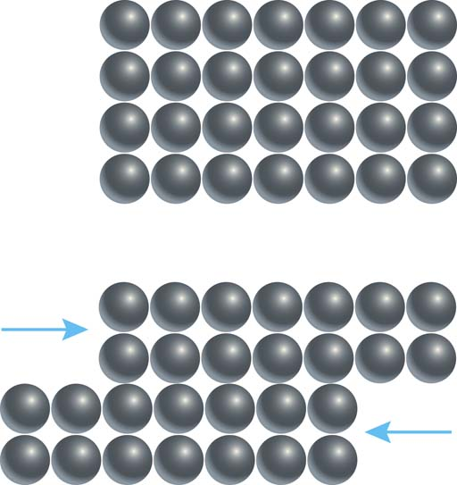

5 Name three structural features that metals have in common.

• Atoms are arranged into layers

• Atoms can slide over one another

• Electrons are delocalised and move freely

6 How does temperature affect conductivity in metals?

Increased temperatures in metals results in lower electrical conductivity

7 Why are metals shiny?

Delocalised electrons reflect light

Word detective – Sequencing

8 Write a number next to each element in the table below, from most conductivity to least conductivity. Then explain where these metals can be used every day. Some have been completed for you.

|  |  |  |  |
| --- | --- | --- | --- |
| Order of conductivity | Element | Electrical conductivity  (× 106 ohm-1 cm-1) | Everyday usage |
| 9 | Lead | 0.048 | In acid batteries |
| 1 | Silver | 0.63 | Electronic devices |
| 7 | Carbon (graphite) | 0.100 | Electrical cells such as batteries |
| 2 | Copper | 0.596 | Electrical fittings and hinges |
| 3 | Gold | 0.452 | Electronic devices |
| 8 | Iron | 0.093 | In vehicles like cars |
| 4 | Aluminium | 0.37 | Outside of power lines |
| 5 | Magnesium | 0.226 | In light alloys in aircraft |
| 6 | Sodium | 0.210 | Glass, textiles and baking soda |

Literacy support worksheet answers

3.8 Nanotechnology involves the specific arrangement of atoms

Pages 84–85

Nanotechnology

1 What unit do we use to measure in nanotechnology?

The nanometre

2 What is the diameter of the average atom?

0.3 nanometres (0.000 000 3 millimetres)

3 How big is a nanobot?

A nanobot is no larger than the width of a human hair.

4 What is nanotechnology?

Nanotechnology is the manipulation of atoms at the nanoscale to develop technology that can operate at a very small scale, and is therefore more specific in its purpose.

5 Name three things nanobots can be used for.

• Boost the immune system

• Repair parts of the body

• Clean up the environment

6 How could nanobots help us to stay healthy?

Nanobots could monitor the body for viruses or bacteria that could cause disease.

7 What properties do metals and carbon nanotubes have in common? (Hint: Use the information on page 84 in the student book to help you.)

Both are extremely hard, have high tensile strength, and are efficient conductors of heat and electricity.

8 What are the differences in properties between metals and carbon nanotubes?

Carbon nanotubes are much lighter and more flexible than metals.

Word detective – Complete the table

9 Complete the following table about carbon nanotubes. List adjectives that could be used to describe carbon nanotubes in the left-hand column. List potential uses for carbon nanotubes in the right-hand column. An example has been completed for you.

|  |  |
| --- | --- |
| Adjectives | Uses |
| Hard | In medicine, to fix damaged brains |
| High tensile strength | To create clothing with unique properties |
| Efficient conductors | In computing and television, to create futuristic TV screens |
| Light | For renewable energy devices such as solar panels |
| Flexible | To break down pollution in waterways |